Tim Minshull个人简历

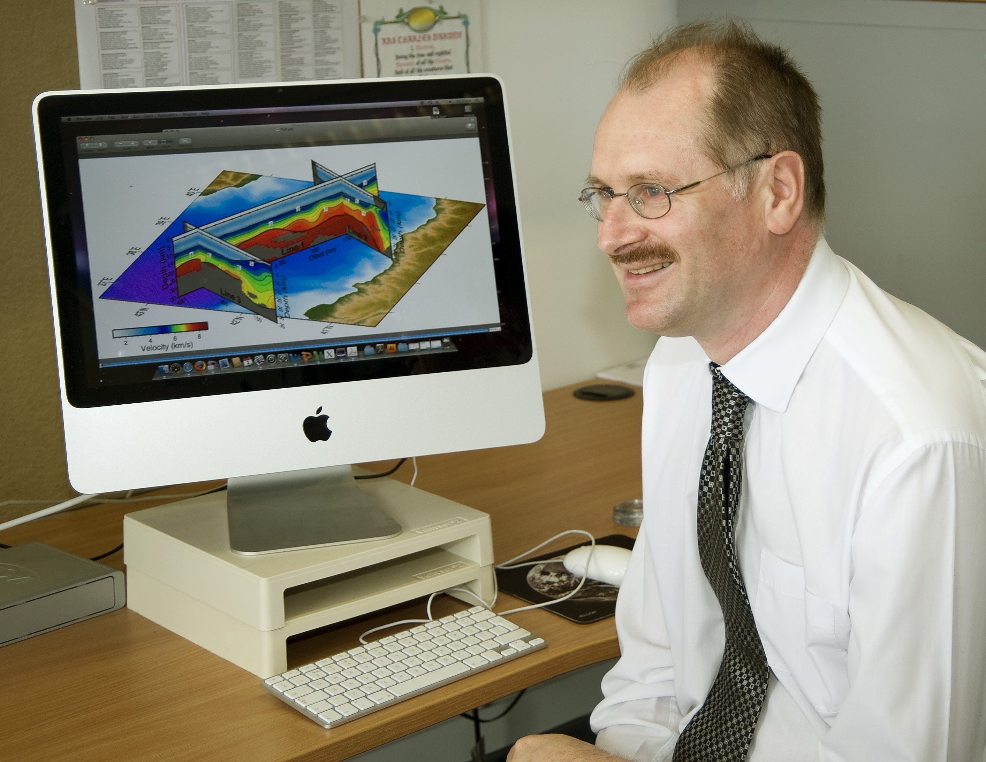
National Oceanography Centre Southampton,
University of Southampton, European Way,
Southampton SO14 3ZH, United Kingdom.
tmin@noc.soton.ac.uk

Tim Minshull graduated in Natural Sciences from the University of Cambridge in 1985, specializing in Physics. He obtained an MSc in Geophysics from the University of Durham in 1986 and in 1990 he completed a PhD in marine geophysics at the University of Cambridge. After a short period as a lecturer at the University of Birmingham, he returned to Cambridge as a Research Associate and subsequently a Royal Society University Research Fellow. In 1999 he obtained a lectureship at the University of Southampton, where he was awarded a Personal Chair in 2004. He has been Head of Ocean and Earth Science at the National Oceanography Centre Southampton since 2009. His research focuses on the application of marine geophysical techniques, in particular controlled source seismology, the study of geological processes in the oceans and on their margins. Interests include lithospheric extension at rifted margins, the seismic characterisation of gas hydrate provinces, and seismic imaging of active volcanoes. In 2003 he led the formation of the UK Ocean Bottom Instrumentation Consortium, which operates instrumentation for controlled source seismology, local earthquake seismology and electromagnetic recording on the seafloor. He is the author or co-author of over 110 peer-reviewed publications.

Selected recent publications:

Minshull, T. A., C. I. Lane, J. S. Collier and R. B. Whitmarsh, The relationship between rifting and magmatism in the northeastern Arabian Sea, Nature Geoscience, 1, 463-467, 2008; Shillington, D. J., C. L. Scott, T. A. Minshull, R. A. Edwards, P. J. Brown, and N. White, An abrupt transition from magma-starved to magma-rich rifting in the eastern Black Sea, Geology, 37, 7-10, 2009; Westbrook, G. K., T. A. Minshull and 18 others, Escape of methane gas from the seabed along the West Spitsbergen continental margin, Geophys. Res. Lett., 36, L15608, doi:10.1029/2009GL039191. 2009; Paulatto, M., T. A. Minshull, and 12 others, Upper crustal structure of an active volcano from seismic refraction/reflection tomorgraphy, Montserrat, Lesser Antilles, Geophys. J. Int., 180, 685-696, 2010; Armitage, J. A., J. S. Collier and T. A. Minshull, The importance of rift history for volcanic margin formation, Nature, 465, 913-917, 2010; Sarkar, S., C. Berndt, A. Chabert, D. G. Masson, T. A. Minshull and G. K. Westbrook, Switching of a paleo-ice stream in northwest Svalbard, Quaternary Sci. Rev., 30, 1710-1725, 2011.

Tim Minshull报告摘要

METHANE HYDRATE DESTABILISATION IN A WARMING OCEAN: EVIDENCE FROM OFFSHORE SVALBARD

By Prof. Tim Minshull

Abstract：
Methane hydrate is the stable form for methane at low temperatures and high pressures in the presence of sufficient water. Atmospheric methane concentrations are well correlated with global sea-level, and isotopic and other evidence have been interpreted to suggest that methane hydrate dissociation has contributed to rapid and extreme episodes of climate change in the geological record. The global hydrate inventory is dominated by the submarine component. Beneath the seabed, the hydrate stability zone (GHSZ) is defined by temperature (dependent on water temperature and geothermal gradient) and pressure (dependent on water depth plus depth beneath seabed), and increases in thickness with increasing water depth. Dissociation of hydrate in response to increased ocean temperature has the potential to produce a rapid release of methane that has accumulated as hydrate over a long time from weak or moderate migration of methane as free gas or in solution. Such methane may reach the seabed through thermally induced contraction of the GHSZ at its landward limit, through transport along the base of the GHSZ to its landward limit, or through chimney-like structures that cut through the GHSZ. In 2008, we discovered hundreds of plumes of bubbles of methane gas rising from the seabed west of Spitsbergen, in the Arctic, in water depths at and shallower than the expected the upper limit of the GHSZ. It is probable that these plumes come from methane released by the dissociation of methane hydrate beneath the seabed, caused by an increase in water temperature near the seabed of 1°C over the past 30 years, which has deepened the top of the GHSZ by 40 m. If so, this is the first known occurrence of methane release from hydrate by ocean warming in modern times. Bubble plumes were also identified at chimney-like structures further seaward. These discoveries have led on to an international research programme to understand the methane escape process and the effects of methane release on the overlying ocean and atmosphere. I will present some results and conclusions from this programme, including a further Southampton expedition in summer 2011.

Stephen J Hawkins 报告摘要
Responses of coastal and nearshore biodiversity and ecosystems to climate change and other impacts
Professor Stephen J Hawkins
Dean, Faculty of Natural and Environmental Sciences
Climate changes both over time and with latitude and therefore needs to be addressed by both broadscale and long-term studies. The talk will outline combining sustained observations, experiments and modelling to describe, understand and forecast the responses of nearshore and coastal biodiversity and ecosystems to climate change. The work draws heavily on time-series of plankton, fish and intertidal organisms collected in the English Channel from 1888 onwards - including personal surveys by SJH of intertidal organisms from 1980 to date. These long-term data sets enable separation of globally driven change from regional and local scale impacts such as fishing and habitat modification. Statistical modelling has enabled simple predictions of likely extent and abundance of key intertidal species. Process based modelling has shown how competition can modulate responses to climate forcing, enabling better simulation of future states under different climate scenarios. In parallel experiments on UK and European scales have highlighted the role of biological interactions, particularly grazing, in shaping community structure and ecosystem functioning. Quite subtle differences in species behavioural traits, as northern species are replaced by southern species, could lead to major shifts in community structure and productivity. In societal adaption to global change it is important to focus on managing the interactions of climate driven processes (that little can be done about in the next 30-50 years) with those impacts such as fishing, pollution and habitat loss that can and should be managed.

